**Assignment-2**

| Assignment Date | 27 September 2022 |
| --- | --- |
| Student Name | Hariharan B |
| Student Roll Number | 921319104047 |
| Maximum Marks | 2 Marks |

**Question:**

1. Create a Flask App
2. Add the Home page, About Page
3. Add the Bootstrap
4. Add the Sign in page and Add the Signup Page

**1.Flask App.py**

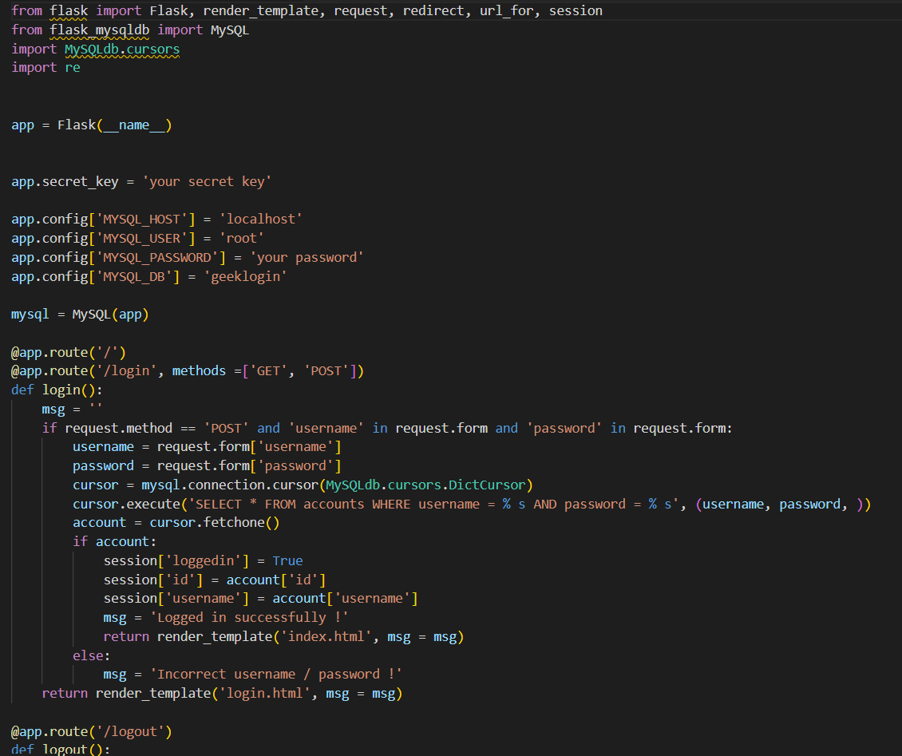

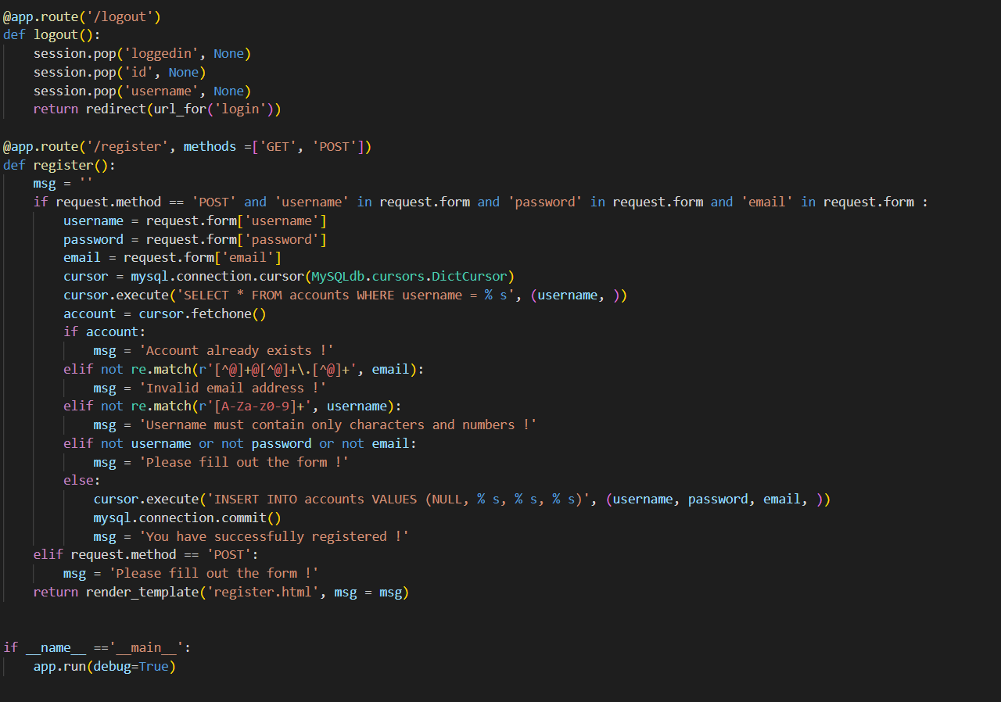

**2. Home Page**

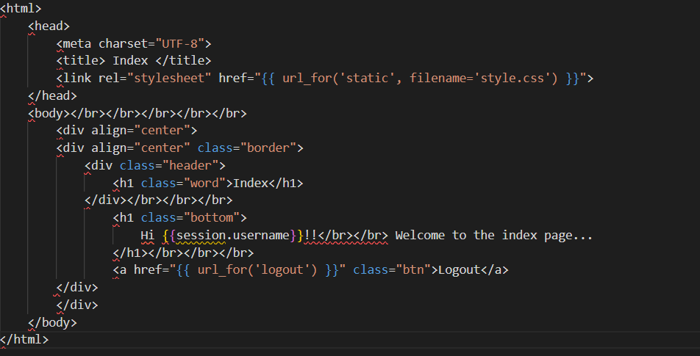

**3. Sign in page:**

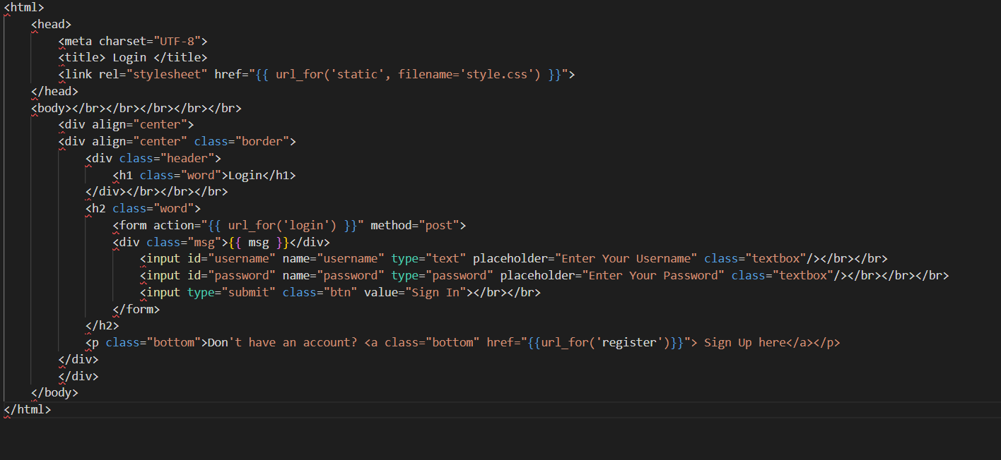

**4.Sign Up page:**

